- NATIONAL
HEALTH
MISSION

2.1 REPRODUCTIVE AND CHILD HEALTH:
- MATERNAL HEALTH:

The most of the strategies and activities have been focused towards provision of quality services, demand generation from the community and making it accessible. There has been a substantial improvement in maternal health indicators of the state. The three ANC check up has shown improvement from 56.2% (NFHS III) to 74.7% (NFHS IV). Further institutional delivery has gone up from 47.2% (NFHS III) to 94.7% (NFHS IV). The percentage of women with anaemia has also decreased from 63.1% (NFHS III) to 23.6% (NFHS IV).
These services are further enhanced under maternal health service delivery by introduction of Common Mother & Child Health Cards, implementation of Mother and Child Tracking System through RCH portal, organizing outreach activities through VHNDs, skilled based trainings, ensuring adequate supplies, IEC & BCC activities and continued supervision and monitoring all levels.

HEALTH INDICATORS

MATERNAL HEALTH INDICATORS | NFHS III  (2005-06) | NFHS IV  (2015-16)
% 1st Trimester registration to total ANC  registration | 57.9 | 76.2
% Pregnant Woman received 3 ANC checkups to Total ANC Registrations | 56.2 | 74.7
% of institutional delivery to total reported deliveries | 47.2 | 94.7
Pregnant women age 15-49 years who are anaemic (<11.0 g/dl) (%) | 63.1 | 23.6

- Janani Suraksha Yojna (JSY) Central scheme implemented through National Health mission

The main objective of this scheme is to help promote institutional deliveries in Government hospitals and health centers for preventing maternal and infant deaths. Under this Scheme, cash incentives are provided as under:-
- Institutional delivery in Rural Health Centre: Rs 1,300/- (Rs 700/- to mother & Rs 600/- to ASHA, which also includes transportation)
- Delivery in urban areas: Rs 1000/- (Rs 600/- to mother & Rs 400/- to ASHA)
- Home Delivery: Rs 500/- to mothers only.
The incentives are given only to BPL, SC & ST mothers.

Performance of Janani Suraksha Yojna (JSY)

Activity | Target | Physical Achievement
Home Delivery | 66 | 03
Institutional Delivery | 2313(R),  90 (U) | 2359 (R)  63(U)
Total | 2469 | 2425(98.2)
*(U=Urban, R= Rural)

- Janani- Shishu Suraksha karyakram (JSSK)

This scheme is for providing absolutely free and no-expense delivery to pregnant women delivering in public/ government health institution, including Caesarean Section. The main features of this Scheme are:-
- Free transportation from home to the Government health facility, between facilities and also drop-back home after 48 hours of delivery.
- Free drugs and consumables, free diagnostics, free blood whenever required and free diet.
- Exemption from all kinds of User Charges.
- Similar entitlements for all sick newborns and infants accessing public health institutions for healthcare services after birth.

Physical Performance of Janani Sishu Suraksha Karakam (JSSK)

Activity |  | Target | Physical Achievement
Pregnant Woman | Free Drugs &Consumables | 7800 | 5163
 | Free diet | 848 | 4420
 | Free Diagnostics | 3711 | 4959
Referral Transport | Home to Health Institution | 5000 | 1979
 | Higher facilities |  | 1516
 | Drop home back |  | 1870

- Maternal Death Review (MDR)

Maternal Death Review (MDR) implemented since 2010 with constitution of MDR Committees at State/ district/ block and facility based MDR Committee. All maternal deaths are reported and reviewed as per the MDR Guidelines. Data are being analyzed and corrective interventions are being taken up to further prevent future maternal deaths.

Fig.1 District Wise Breakup of Maternal Death 2016-17

Fig.2 Cause of Maternal Death

Fig.3 FIRST TRIMESTER REGISTRATION TO TOTAL ANC REGISTRATION

Fig.4 PERCENTAGE OF PREGNANT WOMAN RECEIVED 3 ANC CHECK UPS TO TOTAL ANC REGISTRATIONS

Fig.5 PERCENTAGE INSTITUTIONAL DELIVERIES TO TOTAL REPORTED DELIVERIES

Fig.6 PERCENTAGE OF C/S DELIVERIES (PUBLIC/PVT) TO REPORTED INSTITUTIONAL DELIVERIES

- Delivery point:-
Delivery points are those health facilities which fulfills the Government of India criteria of minimum bench mark of performance in terms of delivery conducted right from PHSCs to districts hospitals. The provision of services for delivery generally serves as an important indicators to access whether the facilities is operational or not. The designated DP where deliveries are conducted should be the first to be strengthened for providing comprehensive RMNCH+A services.

Health facilities functional as Delivery point as per GoI benchmark in the state for 2016-17.

PHSC | PHC | District Hospital | State Hospital
- Simik lingay,  - Bermiok,  - Daramdin  - Samdong Kaluk | 1.East : Pakyong,  Rangpo  Rhenock  Rongli  2.South: Jorthang  Yangang  3.West: Dentam  Richenpong  Sombaria  Tashiding PHC,  4. North: Nil | 1.Namchi 2.Gyalshing 3.Singtam | 1.STNM Hospital

- Pradhan Mantri Surakshit Matritva Abhiyan (PMSMA)
Pradhan Mantri Surakshit Matritva Abhiyan has been launched by the Ministry of Health & Family Welfare (MoHFW), Government of India. The program aims to provide assured, comprehensive and quality antenatal care, free of cost, universally to all pregnant women on the 9th of every month. PMSMA guarantees a minimum package of antenatal care services to women in their 2nd / 3rd trimesters of pregnancy at designated government health
facilities.

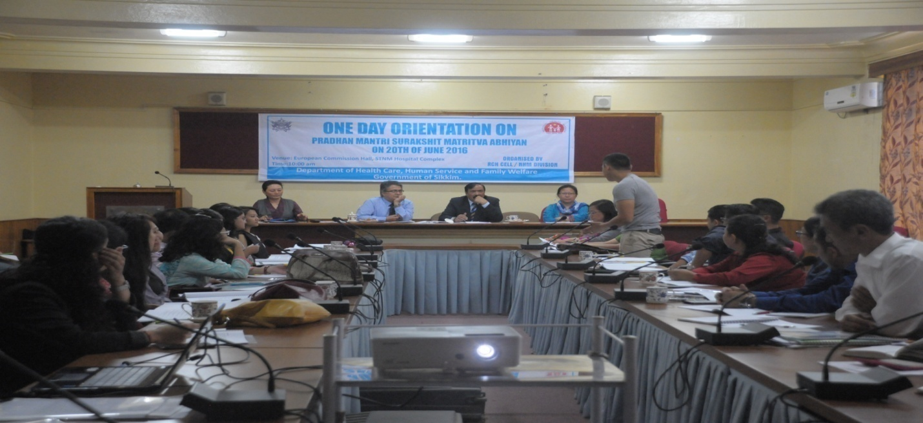

PERFORMANCE OF PMSMA (2016-17)

Month | July | Aug | Sept | Oct | Nov | Dec | Jan | Feb | March | Total
Total no.of beneficiaries received 2nd ANC | 128 | 136 | 33 | 11 | 54 | 78 | 118 | 100 | 81 | 619
Total no.of beneficiaries received 3rd ANC | 103 | 131 | 21 | 14 | 16 | 18 | 6 | 24 | 19 | 352
Ultrasound conducted | 9 | 30 | 31 | 0 | 11 | 4 | 20 | 59 | 64 | 228
High risk PW indentified | 48 | 53 | 23 | 8 | 4 | 2 | 4 | 11 | 3 | 156
High risk PW referred | 9 | 15 | 5 | 0 | 0 | 0 | 0 | 0 | 1 | 30

- CHILD HEALTH:-

The implementation activities under this component include immunization, promotion of optimal Infant and young Child Feeding Practices (IYCF), prophylaxis for anaemia, management of ARI, and diarrhoea with ORS etc.
Under NHM, Newborn Care Corners (NBCC) at all delivery points, Newborn Stabilization Unit (NBSU) at Singtam, Gyalyzing and Mangan District hospital and Sick Neonatal Care Unit (SNCU) at STNM Hospital and Namchi District Hospital have been set up for reducing neonatal and infant mortality.
Further, comprehensive implementations of Facility Based Integrated Management of Neonatal and Child Illness (F-IMNCI), Integrated Management of Neonatal and Child Illness (IMNCI) and Navjat Sishu Suraksha Karyakam (NSSK) have also been introduced for skill development of the health personnel at all levels.

- Janani Sishu Suraksha Karakam (JSSK) for Infants:-

Janani Sishu Suraksha Karakam (JSSK) scheme has been implemented in providing free drugs and consumables, free diagnostics, free blood, free diet & free referral system for newborns & infants admitted in health facilities.
The problems of malnutrition and anaemia are being addressed through close coordination with link workers at the village level. Special intervention methods are adopted to address the problem of anaemia through observed consumption of IFA tablets by all school children along with biannual de-worming.

Performance of Janani Sishu Suraksha Karakam (JSSK)

Activity |  | Target | Physical Achievement
Sick Newborn & Infants | Free Drugs &Consumables | 1321 | 1494
 | Free diet |  | 8
 | Free Diagnostics | 1321 | 1296
Referral Transport | Home to Health Institution | 1321 | 542
 | Higher facilities |  | 121
 | Drop home back |  | 467

- Child Health Indicators

Fig.1 INFANT MORTALITY RATE OF SIKKIM (As per SRS)

Fig.2 DISTRICT-WISE REPORTED INFANT DEATHS (2016-17 State report)

Fig.3 Causes of Infant Deaths (2016-17 State report)

Fig.4 Percentage of Newborn having weight less then 2.5kg to newborn weight at birth

fig.5. Percentage Newborn visited 24hrs of home delivery to total reported home delivery

C. NATIONAL DEWORMING DAY (1ST ROUND 2017-18)

National Deworming Day (NDD) for all children in the age group 1-19 years was observed on 10th March 2017 (All India 10th Feburary, 2017). The objective of NDD is to improve the overall health, nutritional status, access to education and quality of life of children. All the children enrolled in government, government aided and private schools, anganwadi centers and out of school children were deworm.

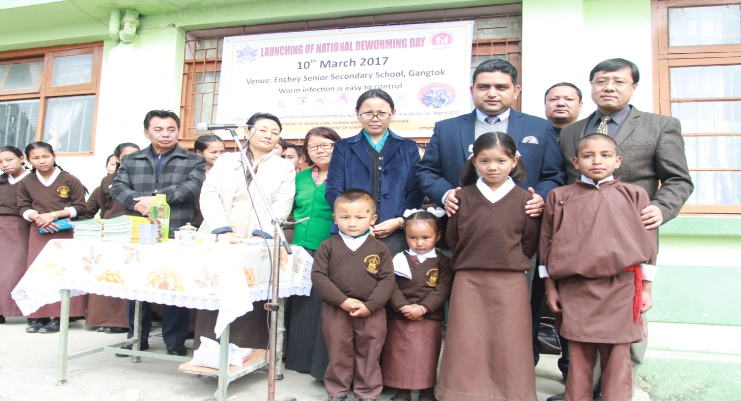

PERFORMANCE OF NDD 2016-17

 | Total number of target children | Total no. Of children who were administered albendazole | Percentage
EAST | 67443 | 62096 | 92
NORTH | 11336 | 8582 | 78
SOUTH | 41454 | 39153 | 94
WEST | 35508 | 32047 | 90
STATE | 155741 | 141878 | 91

D. “MAA” (MOTHER’S ABSOLUTE AFFECTION)
An Intensified Programme was launched in 5th August 2016, in an attempt to bring undiluted focus on promotion of breastfeeding, in addition to ongoing efforts through the health systems. The goal of the “MAA” Programme is to revitalize efforts towards promotion, protection and support of breastfeeding practices through health systems to achieve higher breastfeeding rates. It will be an intensified year long programme for promotion of breastfeeding to bring undiluted focus on promotion of breastfeeding practices.

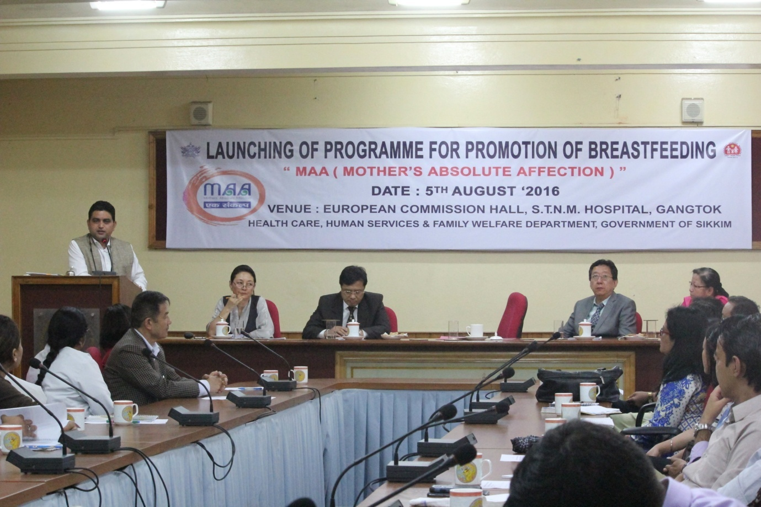

- FAMILY PLANNING

The goal of Family Planning is not only Population Stabilization but also promote reproductive health and reduce maternal, infant & child mortality and morbidity.

- Physical Performance 2016-17

Districts/  State | % Male Sterilization to Total sterilization |  | % Post Partum Sterilizations to Total Female Sterilizations |  | % IUCD insertions in all family planning methods  ( IUCD plus permanent)
 | 2016-17 | 2015-16 | 2016-17 | 2015-16 | 2016-17 | 2015-16
Sikkim | 18.3 | 5.2 | 33 | 38.8 | 90.1 | 89.5
East | 13.9 | 17 | 100 | 100 | 89.7 | 91.1
North | 0 | 0 | 0 | 0 | 100 | 100
South | 20.3 | 0 | 0 | 16.7 | 79.4 | 69
West | 0 | 0 | 0 | 0 | 100 | 100

Fig1.PERCENTAGE PP IUCD INSERTIONS (PUBLIC) TO TOTAL INSTITUTIONAL DELIVERIES (PUBLIC)

- Quality Assurance:-

Under Family Planning, Quality Assurance Committee at State and District level is in place vide office order no:- 188/ HC, HS & FW dated:22/01/2014.
Regular meeting are being conducted to ensure the implementation of the Family Planning programme as per National standards.

As per the supreme court directives the following activities has been taken up:-
- Development of family Planning web page under State NHM Website.
- Empanelled list of doctors uploaded.
- State and District Quality Assurance notification has uploaded.
- Camp approach of Sterilization no more conducted (abolished).

- COMPREHENSIVE ABORTION CARE (CAC):-
Comprehensive Abortion Care (CAC) is planned for all 4 districts and state where Gynecologists are in place. These are being taken up as per the MTP Act which is extended in the state since 19th June 2007. as per State Gov. notification No537/dated 5th December 2007. State and district level committee under MTP Act-1971 in place vide office order no:- 240/HC, HS & FW dated:- 18/08/2014.
V) Blood Strengthening Services:

The state has two blood banks at STNM hospital and Namchi District hospital. Blood storage facilities are established in all the three district hospital (Singtam, Gyalsing and Mangan) and are functional. The blood Banks and the Blood Storage Centre re supported by Nation Health Mission since 2015-16. Supply of consumables, equipments and BCTV vehicle for Namchi District Hospital and Voluntary Blood Donation Camps are supported by National Health Mission.

Total Blood Collection Status:-
Name of the Blood Bank | Year | Total camps conducted | Total blood collected
 |  |  | Total | Voluntary Blood (%)
STNM Hospital | 2015-16 | 22 | 2117 | 1698 (80)
 | 2016-17 (April 2016 to February 2017) | 21 | 2561 | 1741 (68)
Total |  | 86 | 9823 | 6678 (68)
Namchi District Hospital | 2015-16 | 15 | 1009 | 916 (91)
 | 2016-17 | 21 | 1333 | 1249 (94)
Total |  | 64 | 4510 | 4018 (89)

Training:-
Name of training | Approved | Performed | Percentage
SBA training for Staff Nurse | 5 batches | 4 batches | 80
SBA training for ANM/LHVs | 10 batches | 6 batches | 60
Safe Abortion services for MO | 16 MOs | nil | 0
BeMOC for MO | 10 MOs | 10 MOs | 100
RTI/STI for MO | 1 batch | 1 batch | 100
RTI/STI for Lab Tech | 1batch | 1 batch | 100
RTI/STI for ANM/LHVs | 2 batches | 2batch | 100
F-IMNCI training for MO | 1batch | 1 batch | 100
F-IMNCI training for SN | 1 batches | nil | Pending
IUCD training for MOs | 1 batch | 1 batch | 100
IUCD training for SN | 4 batches | 1 batch | 25
IUCD training for ANM | 4 batches | 1 batch | 25
PPIUCD training for Nurses | 4 batches | nil | 0
Availability: Number of institutions providing services |  |  |  | Utilization: Number of MTPs performed-any method
Type of Health Facility | Up to 12 weeks only | Up to 20 weeks : Both 1st and 2nd trimester |  | Up to 12 weeks | 12- 20 weeks
Government (Total) | 4 +1 (STNM) | 1 (STNM) |  | 40 | 3
Private certified (Total) | 1+3 | 1+3 |  | 85 | 0
“Delivery Points” providing services.

PHCs/non FRU CHCs | NA |  |  | -
FRUs (CHCs, SDH etc.) | NA | - |  | - | -
DHs /DWH etc. | 3 +1 (STNM) | - |  | - | -
Medical Colleges | 1 | - |  | - | -
Private certified | - | - |  | - | -

FINANCIAL STATUS FOR 2016-17
Name of programme | Approved Budget 2016-17 (Rs in lakhs) | Total received (Rs. In lakhs) | Expenditure as on 31.3.2017 (Rs. In lakhs) | % of Utilization
RCH II | 1780 | 1085.00 | 1229.86 | 103%
Budget Proposed for the financial years 2017-18:- Rs 546.68 (lakhs)

2.2 IMMUNIZATION:
Vaccines in Routine Immunization (RI) are one of the most cost-effective health investments a country can make. Over the years various strategies to make vaccines universally available, including the most hard-to-reach & vulnerable populations have saved countless lives.
The benefits to the individual include not only the prevention of disease & disabilities but also the opportunity for a healthier & more productive life.
Every child has the right to complete basic immunization irrespective of economic status, political affiliation, geographical location, gender, caste, color or religion. The amazing progress in child survival in the last decade is primarily a result of ever increasing immunization coverage. Universal immunization programme includes vaccines to prevent eight vaccine preventable diseases (TB, Polio, Diphtheria, Pertusis, Tetanus, Measles, Hepatitis ‘B’ & HIB). The State government has introduced MMR vaccine in 2009 to prevent diseases like Mumps, Measles and Rubella. Sikkim is the first state in the country to initiate MMR vaccination along with hepatitis ‘B’ vaccine.
To strengthen routine immunization, newer initiatives have been taken up like :-
- Provision of Auto Disabled (AD) syringe and hub cutter to ensure injection safety.
- Support for Alternate Vaccine Delivery (AVD) from PHCs to PHSCs as well as outreach sessions.
- Mobilization of children to immunization session sites by ASHAs (Rs. 150/- per session).
- Incentives of Rs. 150/- to ASHAs for full immunization of a child.
- Mother & Child Tracking System (MCTS) for tracking of children and pregnant women.
- Quarterly review meetings on immunization are being done at PHCs, districts and state levels.
- For capacity building, training of Medical Officers, Health Workers and Cold Chain Handlers is being organized every year.
- Besides rendering immunization services at all the health facilities, the service is also being reached through Village Health & Nutrition Days (VHNDs) in the anganwadi centers and outreach session in hard to reach areas.
- Cold Chain Officer & Cold Chain Technician is in place to ensure proper cold chain system in the state.
- For efficient vaccine management, various registers, temperature log books & other formats have been printed & distributed to all the health facilities having cold chain points.
- For proper disposal of waste generated following immunization sessions, training of health workers have been done with provision of waste disposal bags, safety pits, hub cutters etc.

Evolution of Universal Immunization Programme (UIP) :-
1978- Expanded Programme of immunization (EPI) BCC, DPT, OPV, Typhoid (Urban Areas)
1983- TT Vaccine for PW added
1985- Universal Immunization Programme (UIP)-Measles added, Typhoid removed
1990- Vitamin -A supplementation
1992- Child Survival & Safe Motherhood
1995- Polio National Immunization Days
2002- Hep ‘B’ Introduced as pilot in 33 districts and 14 cities of 10 states
2006- JE vaccine introduced after campaigns in endemic districts
2007-08 - Hep B expanded to all districts in 10 states and schedule revised to 4 doses to 3 doses
2010- Measles 2nd dose introduced in routine immunization in 14 states
2011- Hep B universalized and Penta introduced in 2 states (Open Vial policy)
2012- Government of India declared the year 2012-13 as the year of “Intensification of Routine Immunization”
2013- Pentavalent expanded to 9 states. JE one more dose added (open vial policy for routine immunization)
2015-Pentavalent vaccine introduced in Sikkim on 7th October 2015
2015-Mission Indradhanush (Phase II) to immunize left out & dropped out children comprising of 4 rounds was launched on 07/10/2015 in North & East District.
2016-Inactivated Polio Vaccine (IPV) was launched in the state of Sikkim on 1st April 2016 and it is being administered to children below 1 year with 3rd dose of Oral Polio Vaccine (OPV) to protect children from Poliomyelitis.
2016-All tOPV vaccines in the state were disposed off as per Government of India guidelines and bOPV vaccines has been introduced. The National switch from tOPV to bOPV took place on 26/04/2016.
2017-Mission Indradhanush (Phase IV) to immunize left out & dropped out children comprising of 4 rounds started on 07/02/2017 in East & West District.
2017-Introduction of Fractional Inactivated Polio Vaccine (fIPV) with 1st dose of Oral Polio Vaccine (OPV) & 3rd dose of Oral Polio Vaccine (OPV) in place of full single dose of Inactivated Polio Vaccine (IPV) w.e.f 7th March 2017.

Acute Flaccid Paralysis (AFP), Measles & Adverse Event Following Immunization (AEFI) Surveillance
- To detect any case of Acute Flaccid Paralysis (AFP) under polio surveillance & serious & severe cases of adverse event following immunization (AEFI), weekly reporting is being done along with measles surveillance from all the PHCs and district hospitals.
- The state and district AEFI committees are in place and investigation reports of every serious AEFI are submitted within 15 days of occurrence.
- Line listing of all AEFI cases is being done at all the health facilities of the state.
AEFI Details 2016-17 as per HMIS report
Number of Cases of Abscess reported following immunization (AEFI) | 5
Number of cases of other complications reported following immunization (AEFI) | 167
Number of cases of death reported following immunization (AEFI) | 2
Pulse Polio National Immunization Day (NID) rounds
2 round of Pulse Polio NIDs for 0 to 5 years children to eradicate Polio are being conducted every year

NID Rounds 2016-17
Rounds | Target (as per District Action Plan) | Achievement
1st (29th January 2017) | 48669 | 44763 (92%)
2nd (2nd April 2017) | 48669 | 45825 (94%)

Full Immunization Coverage
Particulars | Source | Sikkim
Full Immunization Coverage | DLHS 4 | 85.2
 | NFHS 4 | 83
 | HMIS  2016-17 | CNA target (8208)
 |  | 95%

Vaccine-wise Immunization Performance (2016-17) as per HMIS report
Vaccine | Target (as per CNA) | Performance
BCG | 8208 | 7865 (94%)
DPT 1 | 8208 | 0 (0%)
DPT 2 | 8208 | 15 (0%)
DPT 3 | 8208 | 11 (0%)
DPT B | 8208 | 7998 (97%)
OPV 0 | 8208 | 6663 (81%)
OPV 1 | 8208 | 7332 (89%)
OPV 2 | 8208 | 7422 (90%)
OPV 3 | 8208 | 7606 (93%)
OPV B | 8208 | 8180 (100%)
Hep ‘B’ 0 | 8208 | 6099 (74%)
Hep ‘B’ 1 | 8208 | 15 (0%)
Hep ‘B’ 2 | 8208 | 27 (0%)
Hep ‘B’ 3 | 8208 | 42 (1%)
Measles | 8208 | 7930 (97%)
MMR | 8208 | 7818 (95%)
Penta 1* | 8208 | 7355 (90%)
Penta 2* | 8208 | 7424 (90%)
Penta 3* | 8208 | 7589 (91%)
Full Immunization | 8208 | 7822 (95%)
DT (5 yrs) | 10560 (Census 2011) | 8245 (78%)
TT (10 Yrs) | 13543 (Census 2011) | 9594 (71%)
TT (16 Yrs) | 13428 (Census 2011) | 8614 (64%)
Vitamin ‘A’ (1st Dose) | 8396 (CNA) | 5921 (72%)
Vitamin ‘A’ (5th Dose) | 8715 (Census 2011) | 3135 (36%)
Vitamin ‘A’ (9th Dose) | 10560 (Census 2011) | 4494 (43%)
*Pentavalent Vaccine was launched in Sikkim on 7th October 2015

TT for Pregnant Women as per HMIS report 2016-17
Vaccine | Target (as per CNA) | Achievement
TT 1 | 9256 | 6824 (74%)
TT 2 / Booster | 9256 | 7513 (81%)

Other Immunization Performance
Number of Immunization Sessions Planned | 8894
Number of Immunization Sessions Held | 8754 (98%)
Number of Immunization Sessions Held where ASHAs were present | 7618 (87%)
Number of cases of Diphtheria reported in children below 5 yrs of age | 0
Number of cases of Pertussis reported in children below 5 yrs of age | 0
Number of cases of Tetanus Neonatarum reported in children below 5 yrs of age | 0
Number of cases of Tetanus other than neonatarum reported in children below 5 yrs of age | 0
Number of cases of Polio reported in children below 5 yrs of age | 0
Number of cases of Measles reported in children below 5 years of age | 41

2.3 NATIONAL VECTOR BORNE DISEASE CONTROL PROGRAMME:
Introduction:
The National Vector Borne Disease Control Programme (NVBDCP) is an Umbrella Programme for prevention and control of Malaria and other Vector Borne Diseases like Dengue, Filaria, Kala-Azar, Japanese Encephalitis and Chickengunia with special focus on the vulnerable groups of the society. Under the programme, it ensures that the disadvantages and marginalized section benefit from the delivery of service so that the desired National Health Policy and Rural Health Mission Goals are achieved.

Objective of the programme:
- To prevent morbidity due to Malaria and other Vector Borne Diseases.

The main activities under the programme:
- Early Diagnosis and complete treatment.
- Integrated vector control.
- Community based health education.
- Training and capacity building of various cadres of medical and paramedical staff for prevention, management and control of Vector Borne Diseases.
- Effective Monitoring, supervision and surveillance.

Organisational setup:
The NVBDCP wing of the Health Department is situated at Head Quarter, Gangtok, having overall responsibilities of implementation of programme.
In the East District – District NVBDCP Office and store is situated at Singtam Old Hospital Complex, where insecticides and anti – malarial drugs are stored and supplied to all four (04) districts.
There is no NVBDCP Office at North, South and West District; the Programme is implemented under the supervision of District malaria Officer / Chief Medical Officers.
Malaria Problem in Sikkim:
Malaria is prevalent:
- Among migrant population in project areas and construction sites.
- Army personnel transferred from malaria endemic areas.
- Local population in lower belt of the state.

Activities For malarial areas of the state
- Identification of the high risk areas.
- Increase in ABER by training of MPHWs.
- Monthly meeting with the MO, I / C PHC & CMOs.
- Involvement of Private Practitioners in monthly reporting of malaria cases and death.
- Monitoring and evaluation.

Inspite of getting majority of imported cases from neighboring States and Countries and resurgence of malaria in recent years, the malaria situation in Sikkim is not very bad.
Statement showing malaria situation from 2012-2016
Name of State:Sikkim
Year | Population | BS | Total Positive Cases | No of Pf cases | No of  Death | ABER  (%) | SPR  (%) | PF  (%) | API  (%) | SFR  (%)
2012 | 193302 | 6574 | 77 | 14 | NIL | 3.40 | 1.17 | 18.1 | 0.03 | 0.21
2013 | 198136 | 11136 | 38 | 13 | NIL | 5.6 | 0.34 | 34.21 | 0.01 | 0.11
2014 | 203089 | 7970 | 35 | 18 | NIL | 3.9 | 0.43 | 51.4 | 0.01 | 0.22
2015 | 208166 | 8826 | 27 | 13 | NIL | 4.23 | 0.30 | 48.1 | 0.01 | 0.14
2016 | 213370 | 8099 | 15 | 05 | NIL | 3.79 | 0.18 | 33.3 | 0.007 | 0.06

Statement showing vector borne disease situation from 2012 to 2016:
YEAR | MALARIA | FILARIASIS | KALA - AZAR | DENGUE
2012 | 74 | Nil | 05 | 07
2013 | 38 | Nil | 07 | 679
2014 | 35 | Nil | 06 | 03
2015 | 27 | 01 | 05 | 35
2016 | 15 | Nil | 01 | 42

Entomological component
The Entomological component under NVBDCP is a vital one. In view of the presence of vector species of Malaria, Kala - Azar, J.E, Filaria and Dengue in the low lying areas bordering West Bengal. Strengthening of Entomological staff with logistic is must.

IEC
This is one of the most important components of the programme. All the media of the state are being used to spread the message of prevention and control of malaria and other vector borne diseases in collaboration with IEC Bureau.
Anti – malaria month is observed during the month of June every year.
Anti – Dengue month is observed during the month of July.
World Malaria Day is observed on 25th April.
National Dengue Day is observed on 16th May.
This year more emphasis will be given to project areas.

Action Plan proposed for project areas during 2017-18.
- Screening of labour population.
- Sensitization of the MPHW catering project areas / construction sites.
- Intensive IEC activities.
- Sensitization of the Private Practitioners and Panchayats of the area.
- Mass survey of the labour population.
- Buffer stock of the anti malarial drugs in the PHC catering the project areas.
- Sensitization of the Medical Officer for early prediction of the epidemics.
- Training of the Medical Officers & Paramedical staff including Lab. technician of the project areas.
- Constant supervision and monitoring.

Financial statement
STATE: SIKKIM
Year | Fund proposed | PIP approved | Fund released by GOI | Expenditure | Balance
2016-17 |  | 15.27 | 15.27 | 12.21 | 3.06
2017-18 | 28.00 | Nil | Nil | Nil | Nil

2.4 Integrated Disease Surveillance Program

INTEGRATED DISEASE SURVEILLANCE PROGRAMME
(2016-17)
- BACKGROUND

At national level Integrated Disease Surveillance Programme (IDSP) was launched by Hon’ble Union Minister of Health & Family Welfare in November 2004. It is a decentralized, State based Surveillance Program in the country. It is intended to detect early warning signals of impending outbreaks and help initiate an effective response in a timely manner.
Major components of the programme are:
(1) Integrating and decentralization of surveillance activities;
(2) Strengthening of public health laboratories;
(3) Human Resource Development – Training of health care workers involved
(4) Use of Information Technology.

In Sikkim, Integrated Disease Surveillance Project was launched in Ph III (2006-07) on 1st April 2006.

Currently surveillance is working on three aspects of diseases surveillance.
- Syndromic
- Presumptive
- Confirmed

- ▪ Syndromic - Diagnosis made on the basis clinical pattern by paramedical personnel and members of community. This include fever, fever with rashes, fever with bleeding, diarrhea without dehydration, diarrhea with so much dehydration, diarrhea with blood, cough less than 3 weeks and more than 3 weeks, fever with daze or semi/unconsciousness.

- ▪ Presumptive - Diagnosis is made on typical history and clinical examination by medical officers. This includes Acute Diarrheal diseases, Acute Respiratory Diseases, Measles, Chicken Pox, Dengue, Bacillary Diarrhea, Viral Hepatitis, Enteric fever, Malaria, Chikungunya, Acute Encephalitis syndrome, meningitis, diphtheria, pertusis, pneumonia, Fever of unknown disease, acute paralysis, leptospirosis, dog-bite, snake bite.

- ▪ Confirmed - Clinical diagnosis by medical officer and or positive laboratory identification. This includes typhoid fever, dengue, hepatitis, malaria, tuberculosis, cholera, shigella dysentery, diphtheria, chikungunya, meningococcal meningitis, leptospirosis and others.

In 2013 Vaccine Preventable Disease (VPD) Surveillance and Unnatural deaths and suicidal surveillance was initiated.

- CURRENT STATUS- FINANCIAL AND PHYSICAL

PHYSICAL STATUS OF IDSP
- Manpower of IDSP, Sikkim
Designation | SSU | DSU | Medical Collage(CRH) | Total | Nature of Post | Status
SSO | 1 | 0 | 0 | 1 | Regular | Active
DSO | 0 | 4 | 0 | 4 | Regular | Active
Training Consultant | 1 | 0 | 0 | 0 | Regular | Inactive
Epidemiologist | 1 | 0 | 0 | 1 | Contractual | Inactive
Entomologist | 0 | 1 | 0 | 1 | Contractual | Active
Financial Consultant | 1 | 0 | 0 | 1 | Contractual | Active
Microbiologist | 0 | 2 | 0 | 2 | Contractual | Active
Data Manger | 1 | 4 | 0 | 5 | Contractual | Active
DEO | 1 | 4 | 1 | 6 | Contractual | Active
Lab Technician | 1 | 0 | 0 | 1 | Contractual | Active

Human Resource Development – To provide better technical expertise to system GOI has provided contractual staffs (Epidemiologist, Entomologist, Vetenary Consultant, Financial consultant, Microbiologists, Data Managers, Data Entry operators and others). Presently a total of 22 staffs are working in IDSP in which 16 staffs are on Contractual Basis. There is also a provision of capacity building for all human resource available in the State through routine training of health care workers involved in IDSP. For this purpose GOI provides a separate fund.

- Use of Information Technology – All DSUs and SSU is well allied with Telephone, Fax Machines, Computers with Internet, EDUSAT & VSAT application facilities. Routine data is entered through the web based IDSP-portal (www.idsp.nic.in), VSAT has been installed in three Districts (except North District), State and Medical College Manipal, Hospital.
At present EDUSAT & VSAT facilities has been disrupted from the CSU due to no signal across the country.

EDU-SAT/ V-SAT STATUS

Sl.No | State/District | EDU SAT / VSAT | Broadband
1 | State Surveillance Unit | Installed*** | Working
2 | Medical Collage Manipal | Un Installed due to shifting of room. | Not Installed
3 | East | Installation incomplete | Working
4 | West | Installed *** | Not Working
5 | North | Not installed due to lack of equipments. | Not Working
6 | South | Installed *** | Working
*** EDUSAT & VSAT facilities have been disrupted from the CSU due to no signal.

Note:-Inter- state wise VC session is done with CSU Delhi every Friday at 3.30pm – 4.30pm.

- Capacity building (Workshops and training)
Sl NO | Trainees | Year of Training | Total Trained
1 | MPHW/ANM/GNM/AWW | 2016-17 | 121

- Committee and surveillance
State Surveillance Unit and District Surveillance Unit were established in year 2006. In all four Districts and State RRT (Rapid Response Team) for outbreak investigation and control are in function. These RRTs were framed in year 2007-08. State and district Influenza epidemic preparedness and response committees formed in Jan 2009.The framed State & District RRT has been revised on 2015-16. Also to tackle EBOLA & other Influenza like Illness (Swine Flu) hospital management committee has been formed consisting of dedicated staffs’ at STNM Hospital and CRH Tadong.

- PROGRAMME PLAN OF FINANCIAL YEAR (2016-17)
- Physical Achievements.

- Entomological survey conducted at Hot-belt areas of the State regarding Vector borne Diseases.
- On 30th May 2016, meeting on prevention of rabies cases with Veterinary Department Officials at the chamber of PDHS-I Health secretariat.
- On 9th to 11th June attended IDSP review meeting at Jaipur Rajasthan.
- On 23rd July 2016, dispatched 100 bottles (vials) for blood culture at Department of Microbiology STNM Hospital.
- On 18th August 2016, visited landslide area at upper Dzongu 4th mile Mantam Village under Passingdong PHC with Hon’ble Ministers (Health/UDHD/ PHE), parliamentary Secretary, Deputy Speaker, food Secretary and health officials and staffs.
- On 20th & 21st September 2016, State Data Manager IDSP attended Hands-on- Training on “Data Management and Information & Communication Technology” at NCDC Delhi.
- On 19th October 2016, meeting conducted at European Commission Hall STNM Hospital with ICMR Delhi and HoD Microbiology regarding the establishment of Virus Research and Diagnostic Laboratory (VDRL), at new under constriction Super Specialty Hospital, Sichey, Gangtok.
- Started P-Form reporting form Urban Health Post Tadong under CRH 5th mile Tadong.
- Procured one Elisa Reader and Washer for District Public Health Laboratory (DPHL), at District Hospital Gyalshing.

- FINANCIAL STATUS OF IDSP
Financial Status for the year 2016-17 (Till March 2017) Under IDSP
Year | Approved Outlay | Opening Balance | Fund Received |  |  | Total Fund Available column (3+6) | Expenditure | Unspent Balance
 |  |  | Central | State | Total Col(4+5)
1 | 2 | 3 | 4 | 5 | 6 | 7 | 8 | 9
2016-17 | 49.57 | 14.21 | 37.50 | 0 | 37.50 | 51.71 | 46.35 | 5.36

DISEASE OUTBREAKS DETECTED IN THE STATE OF SIKKIM UNDER IDSP
(FY.2016-17)

Outbreaks | Source of data for identification of these outbreaks | Outbreaks investigated by State / District RRT | Remarks
Measles Outbreak at JNV School under Phodong PHC North District on 16th March 2016. | Reported by MO/IC Phodong PHC | Investigation done by District RRT Members, District IEC Officer and MO/IC | Controlled in time
Chicken pox outbreak at Pulung labing under Yaksum PHC West District on 28th April 2016. | Reported by MO/IC Yaksum PHC | Investigation done by District RRT Members and MO/IC | Controlled in time
Human Rabies cases reported from South and West District of the State. | Reported by Medical Officer | Investigation done by Department of Microbiology STNM Hospital and Medical Specialist | 5 death reported.

Photos
On 19th Oct 2016, Meeting on Establishment of Virus Research and Diagnostic Laboratory (VDRL).
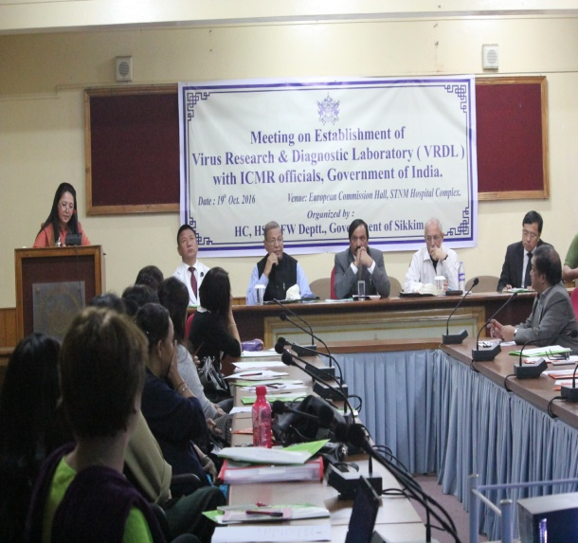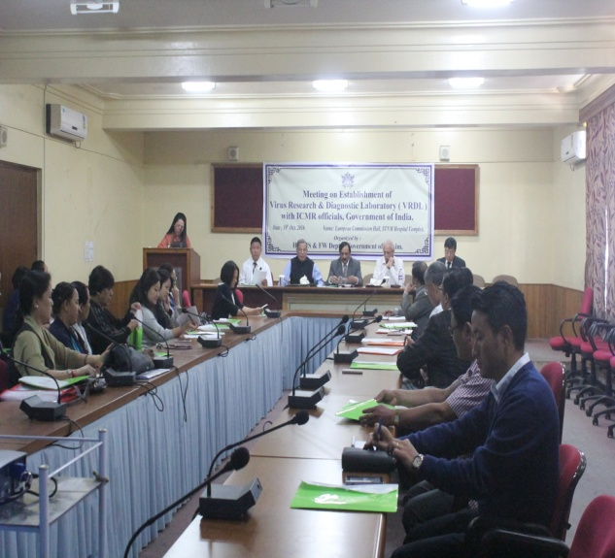
On 18th August 2016 visited landslide area at upper Dzongu 4th mile Mantam Village under Passingdong PHC
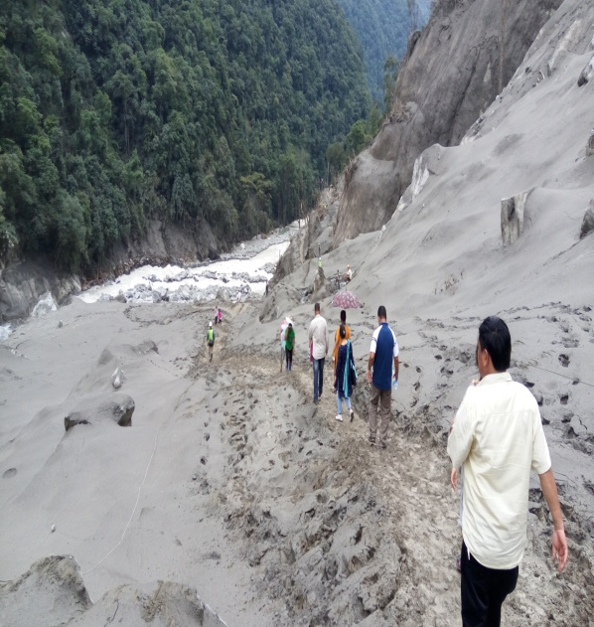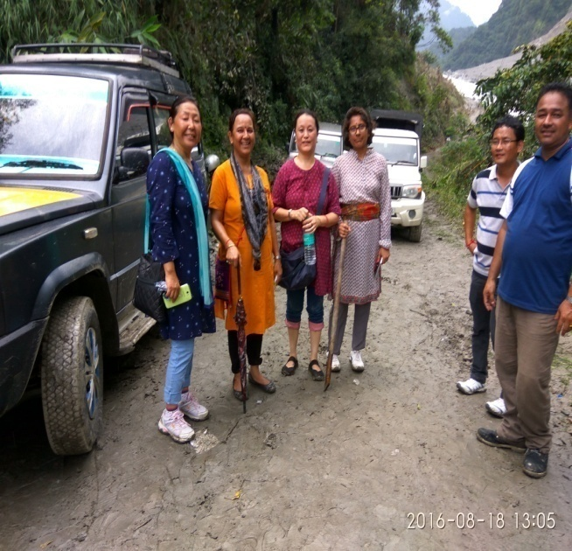

Entomological Surveys.
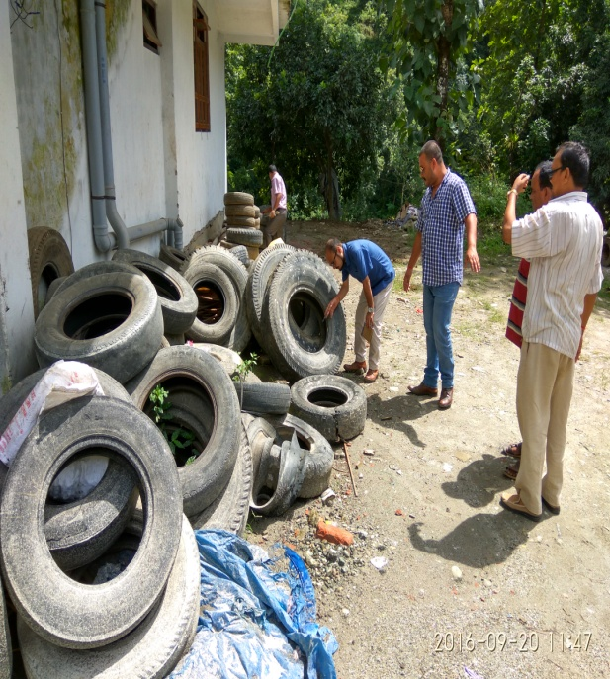

One Day Orientation cum Training for MPHW,s/ANM,s/GNM,s at District Hospital Gyalshing West Sikkim on 11th June 2016.
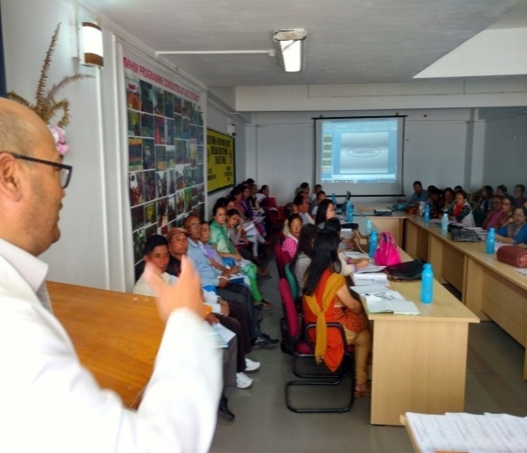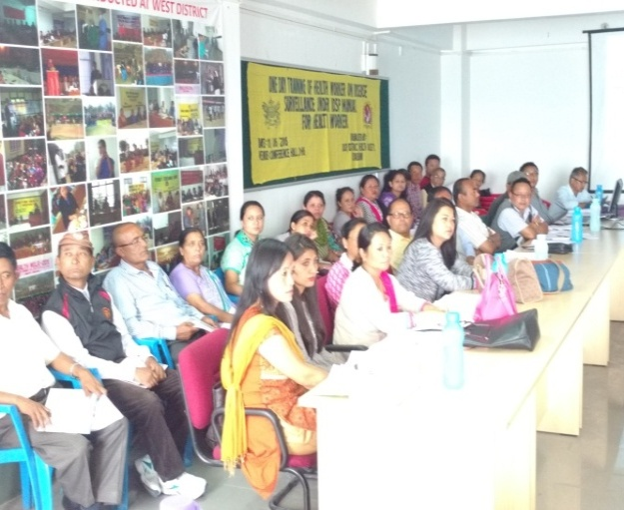

One Day Orientation cum Training for MPHW,s /ANM’s GNM’s at District Hospital Namchi South Sikkim on 30th March 2017.

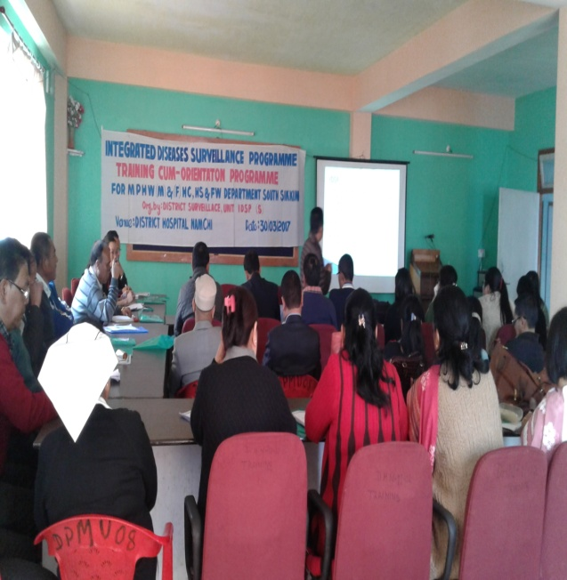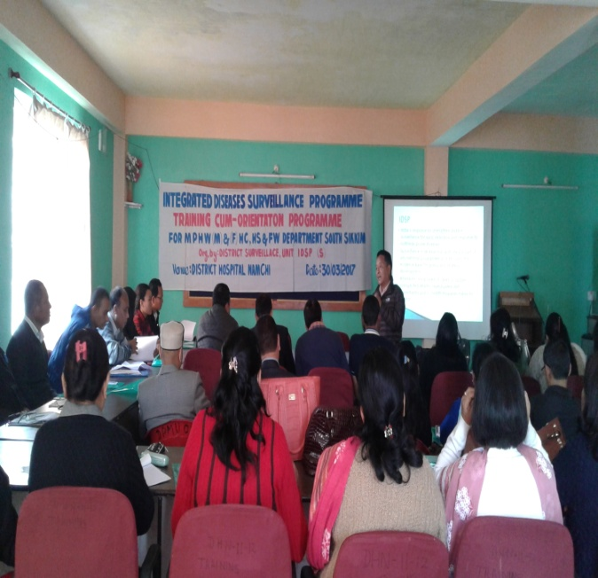
One Day Orientation cum Training for MPHW,s /ANM’s GNM’s at District Hospital Singtam East Sikkim on 30th March 2017.
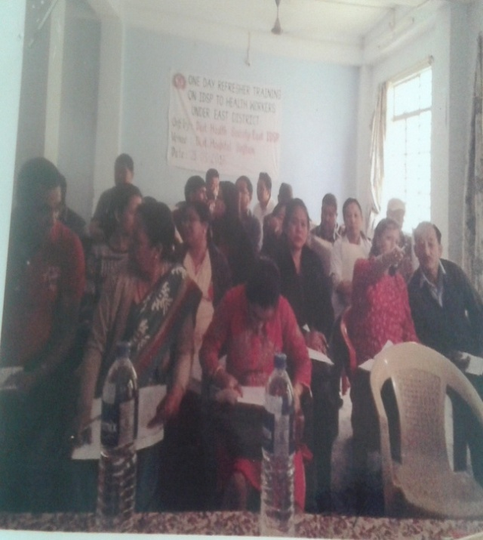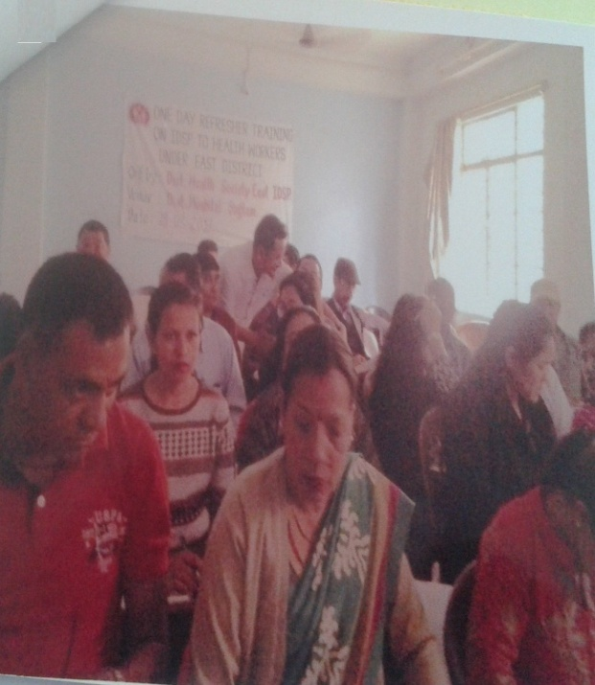

2.5 Revised National Tuberculosis Control Programme
On initiative of the Government of India, Revised National Tuberculosis Control Programme is one of the state run tuberculosis control programme running smoothly since 1st March, 2002.
It incorporates the principle of Directly Observed Treatment Short- Course (DOTS), which is the global strategy of World Health Organisation (WHO).
DOTS and its 5 Components:
- Political and administrative commitment
- Good quality diagnosis.
- Good quality drugs.
- Supervised treatment to ensure the right treatment.
- Systematic monitoring and accountability.

The main Objectives of the RNTCP:
Early detection and treatment of atleast 90% of estimated all types of TB cases in the community (including Drug Resistant and HIV associated TB)
To attain the objective of RNTCP, The following infrastructure has been set up:
- State TB Cell (STBC): Headed by Additional Director cum STO, oversees the whole RNTCP programme in the state.
- District TB Centre ( DTC): Total of five (5) District TB Centres across the state with District TB Officers as Programme Officers to oversee the TB control activities of their respective districts
- Tuberculosis Units (TU): It is a nodal unit in TB Control programme where registrations of patients are done. There are five (5) TUs in the state presently.
- Microscopy Centres: There are total thirty one (31) Microscopic Centres.
- Intermediate Reference Lab. (IRL) . The state boasts an IRL where CBNAAT facility and solid C&DST is done.

- Cartridge Based Nucleic Acid Amplification Test( CBNAAT) centres. There are 4 CBNAAT machines installed in IRL, Gangtok and in District Hospitals at Geyzing, Mangan and Namchi respectively and is functioning. Two more CBNAAT machines to be installed in Singtam DTC and Medical College shortly.
- Drug Resistant TB Centre = There is one Nodal Drug Resistant TB centre at STNM complex, Gangtok with 10 beds and link DR TB Centres in all the districts.
Achievements and Innovation
- Universal DST offered to all TB patients leading to early diagnosis and treatment with an overall aim to cut chain of transmission and subsequently improve DRTB treatment outcome.

- Daily Directly Observed Treatment (DOT) regimen implemented in Sikkim w.e.f. Feb. 2017

- 99DOTS started from January 2017 for PLHIV patients

- GIS mapping of Drug sensitive/ drug resistant TB cases

CURRENT STATUS –Financial and Physical

Fund received and Expenditure during 2016-2017
- State Plan fund

Budget | 2016-17
Estimated | 73.49
Expenditure | 73.49

(ii) Budget Summary under RNTCP for the year 2016-17

Sl. No. | Particulars | Amount
1 | Opening Balance | 376,738
2 | GOI Grants | 202,40,000
3 | Grant from State Govt. State Share | 66,00,000
4 | Bank Interest | 98,322
5 | Other Income – cancellation of stale cheques | 50,200
Receipts TOTAL |  | 2,73,65,260
6 | Loan from NHM returned during the year | -30,00,000
 | Actual Fund available during the year | 2,43,65,260
7. | Expenditure during the year (31.03.2017) | 2,39,00,422

2.Physical Target and Achievement (2016)
Sl.No. | INDICATORS | TARGET | 2016
 | Total TB patients registered for Treatment |  | 1455
 | NSP Death rate | <5 | 3%
 | Total Case Detection Rate | 167/ per lakh Population | 231/ lakh population
 | Cure Rate | >85% | 79%
 | MDR-TB total patients registered | - | 241
 | MDR-TB cure rate | 40% | 61%
 | XDR-TB total patient registered | - | 22

2.6 National Programme for Prevention and Control of Cancer, Diabetes, Cardiovascular Diseases and Stroke.
(NPCDCS)
Introduction
Non- Communicable Disease (NCD), also known as chronic disease includes cardiovascular diseases, diabetes, stroke and most forms of cancers and injuries. Such diseases mainly result from lifestyle related factors such as unhealthy diet, lack of physical activity and tobacco use. Changes in lifestyle, behavioural patterns, demographic profile (aging population), socio-cultural and technological advancements are leading to sharp increase in the prevalence of NCD. These diseases by and large can be prevented by making simple changes in the way people live their lives or simply by changing our lifestyle.
To contain the increasing burden of Non-Communicable Diseases, Ministry of Health and Family Welfare, Government of India has initiated the National programme for Prevention and control of Cancer, Diabetes, Cardiovascular diseases and Stroke (NPCDCS) which focuses on health promotion and prevention, strengthening of infrastructure including human resources, early diagnosis and management and integration with the primary health care system through NCD cells at different levels for optimal operational synergies.
The NPCDCS Programme was initiated at 2 Districts (East and South) of Sikkim in year 2010-11.
Objectives:
- Health promotion through behavior change with involvement of community, civil society, community based organizations, media etc.
- Screening at all levels in the health care delivery system from sub-centre and above for early detection of diabetes, hypertension and common cancers. Outreach camps are also envisaged.
- To prevent and control chronic Non-Communicable diseases, especially Cancer, Diabetes, CVDs and Stroke.
- To build capacity at various levels of health care for prevention, early diagnosis, treatment, IEC/BCC, operational research and rehabilitation.
- To support for diagnosis and cost effective treatment at primary, secondary and tertiary levels of health care.
- To support for development of database of NCDs through Surveillance System and to monitor NCD morbidity and mortality and risk factors.

ORGANIZATIONAL SETUP:

- State NCD Cell:
At the state level there is State NCD Cell which is responsible for overall planning, implementation, supervision, monitoring, and evaluation of the different activities under three national programmes namely National Programme for Prevention and Control of Cancer, Diabetes, Cardiovascular Diseases and Stroke (NPCDCS), National Programme for Health Care of Elderly (NPHCE) and District Mental Health Programme (DMHP).
The Additional Director Health Services is the State Nodal Officer cum State Programme Officer, who is assisted by Joint Director from State Health Cadre and one Finance cum Logistic Officer and other contractual staffs under the programmes.

- District NCD Cell:
At district level only east and south districts have District NCD Cell functioning under the supervision of senior doctors who are designated as District Nodal Officers. He/ She is assisted by one Finance and Logistic Officer and one DEO who are hired on contractual basis under NPCDCs for implementation and evaluation of the different activities at the district level.

- District NCD Clinic:
These two districts have set up District NCD Clinic where regular NCD Clinic for screening, management, and counselling and awareness generation on NCD is done. Comprehensive examinations of patients referred by sub centres and PHCs/ health workers are taken care of by the District NCD Clinic. Creation of public awareness, re orientation of primary health care providers for early detection and referral are an important part of NCD Clinic.
The clinic is run by Medical Specialists supported by one Staff Nurse, Counsellor and DEO. Additional Physiotherapists are posted to these districts to provide uninterrupted physiotherapy services as well as to meet up the demand of the rising NCDs and elderly patients.

NCD Clinic Data for FY 2016-17
Sl.No. | Indicators |  | Person Checked  (FY 2016-17)
1. | No. of persons attended NCD Clinic |  | 72,173
2. | New Patients Diagnosed with | Diabetes | 1551
 |  | HTN | 3673
 |  | HTN &DM | 1097
 |  | CVDs | 120
3. | Persons put on Treatment | Diabetes | 1349
 |  | HTN | 3365
 |  | HTN & DM | 317
 |  | CVDs | 115
4. | No. of person treated at CCU | CVDs | 58
 |  | Strokes | 82

Physical Achievement for FY 2016-17:
Sl. No | Activities | Achievements
 | Training | - 2 Days State Level Training for 38 Medical Officers on NPCDCS w.e.f. 10th – 11th June 2016.  - 5 Days District Level Training for 31 ASHA at Pakyong on Population Based Screening of NCDs. w.e.f. 4th – 8th February 2017  - 5 Days District Level Training for 42 ASHAs of South District on Population Based Screening w.e.f. 2nd – 7th of April 2017.  3 Days District Level Training for Health Workers
 | IEC for Awareness Generation and community mobilization activities | - State level observation of the World Health Day with theme on Beat Diabetes with the presence of Hon’ble Chief Minister.  - District level World Health Day with theme on Beat Diabetes  - Awareness generation in collaboration with Sikkim Tourism dept. during the “Sikkim Running & Living - 25 Kilometer Marathon” at Gangtok.  - Long distance marathon sponsor to spread messages on Healthy Habits, Healthy Living and Healthy Sikkim.  - Doctors Run marathon from Singtam to Rangpo – to spread the message on NCD and role model concept for healthy lifestyle behaviour with involvement of health staffs.
 | Drugs& Consumables | - Procurement of Glucometer, Gluco Strips and Lancet  - Procurement of consumables for Cervical Cancer Screening Equipment, Rapid Pap Smear Kit and lab, consumables )

Financial Achievement FY 2016-17:

 | Activities | Approved Budget as per RoP  FY 2016-17  (Rs. In Lakhs) | Opening Balance as on 1st April 2016  (Rs. In Lakhs) | Amount Received from GoI  (Rs. In Lakhs) | Expenditure in FY  2016-17  (Rs. In Lakhs) | Bank Balance as on 31st March 2017  (Rs. In Lakhs)
A. | Non –Recurring: |  |  |  | 4.51 | -
B. | Recurring grant: |  |  |  |  | -
1 | Human Resource Salary | 80.48 |  |  | 64.42
2 | Laboratories , Drugs & Consumables | 25 |  |  | 4.94
3 | Mobility , Miscellaneous &Contingencies | 30 |  |  | 11.86
4 | Information, Education &Communication&Training | 16.5 |  |  | 11.35
5 | Other Activities (Procurement of Gluco meter, Strip etc. & Printing of registers) | 29 |  |  | 13.01
 | Total | 180.98 | 134.58 | NIL | 105.58 | 29
Gap Analysis
- Budget under NPCDCS:
As per the RoP of 2016-17, a resource envelope of Rs. 1.27 crore was approved for Non Communicable DiseaseFlexipool. The funds under NCD Flexipool cover the programmes like NPCDCS, NPHCE, DMHP, NPCB and NTCP.
However,no resources were received during the FY 2016-17.

- Human Resource
In the FY 2015-16, GoI approved NPCDCS Programme for the north and west districts. However, due to non-recruitment of human resourcesthe programme could not be extended to these two districts.

Financial Proposal for the FY 2017-18 submitted to GOI which is under for approval. Hence, the physical and financial targets will be submitted only after the approval from GOI.

2.7 National Tobacco Control Programme
Background:

Every 6.5 seconds someone dies from tobacco use, says World Health Organization. EVERY YEAR Tobacco kills 5.4 million people in the world which may go upto 10 million by 2025. More than 80% of these deaths occur in the developing countries. Tobacco smoke is major cause of illness disability and premature death globally. It kills more people than AIDS, Alcohol, Other addictions and accidents annually. In India alone 8-10 Lakhs people die due to tobacco related diseases which can be prevented. (Almost 30% of cancers in India are related to tobacco use). Prevalence of Tobacco use in Sikkim was 18.7% in female and 61.8% in male (National Family Health Survey II).

Cigarette and Other Tobacco Product Act, 2003 has been fully extended in the State of Sikkim,State achieved the Status of Smoke Free State in the year 2010. Department of HC, HS& FW, Government of Sikkim is the Nodal Department implementing the Act. The State Tobacco Control Cell is located in Annexure Building, HC, HS& FW Department ,Convoy Ground Tadong. Similarly three districts tobacco cells have been established and functional in District Hospital Singtam (East) Namchi (South) &Gyalshing (West). Tobacco Cessation Centre in STNM Hospital, District Hospital Singtamand Namchihas been established and operational.State Tobacco Control Cell is headed by Additional Director cum SNO, NTCP and supported by the officials of the Sanitation cell of the department. District Nodal Officers under NTCP in the three districts has also been identified . However, North District were not included under NTCP programme, However activities related to NTCP were guided and supported from State Tobacco Control Cell, Head Quarter , Convoy Ground, Tadong, Gangtok .

Goals and Objectives:

The goal of Sikkim tobacco control programme is “Tobacco Free Sikkim”.

The objectives of tobacco control programme are as under:

- To build up capacity of the State/Districts to effectively implement the tobacco control initiatives;
- To train the health care workers, social workers, police personnel, school teachers and panchayats.

- To strengthen the regulatory mechanism to monitor/ implement the tobacco control laws.
- To protect minors and youths from tobacco menace.
- Provide facilities for treatment of dependence.
- To conduct adult tobacco survey/youth survey for surveillance.
- To coordinate with various public and private sector for effective implementation of tobacco free laws.

Following activities were carried out during the financial year 2015-16:

- Monitoring/Raids in various public places to ensure smoke free status of the state.
- Sensitization/Awareness programmes for nodal teachers & Discipline Captains from selected Schools at the District and State Level by DTCC and STCC.
- Printing of booklet “National tobacco control programme – a guide for teachers”, Challans, No Smoking Signages, IEC materials.
- Sensitization/Awareness programmes for Local taxi drivers association , newly recruited police personnels at State and District Level,
- Training of Stakeholders at Singtam.
PHYSICAL AND FINANCIAL REPORT UNDER TOBACCO CONTROL PROGRAMME FOR THE YEAR 2015-16.
STATE LEVEL
Sl. No. | Activities |  | Approved Budget |  | Expenditure | Balance
1 | Training |  | 17.0 |  | 3,82,240/-
2 | IEC |  | - |  | 5,58,901/-
3 | Monitoring / Raids |  | - |  | 68,400/-
4. | School Programme |  | - |  | 1,10,000/-
 | TOTAL |  | - |  | Rs.11,19,541/- | Rs. 580459/-
EAST DISTRICT
Sl. No. | Activities | Approved Budget |  |  | Expenditure | Balance as on 31st March 2016
1 | Training | Rs. 5.0 + RS. 30329 (Opening Balance) |  |  | 1,68,125/- | -
2 | IEC | - |  |  | 1,80,000/- | -
3 | Monitoring | - |  |  | 73750/- | -
4 | Miscellaneous Expenses | - |  |  | 8600/- | -
5 | School Programme | - |  |  | 80000/- | -
6. | Refund to NPCDCS | - |  |  | 10,000/- | -
 | TOTAL EXPENDITURE | - |  |  | Rs. 5,20,475/- | Rs. 9454/-
 | Interest earned |  |  |  |  | Rs. 4130/-
 | Balance as on 31st March 2016 |  |  |  |  | Rs. 13984
WEST DISTRICT
Sl. No. | Activities |  | Approved Budget | Expenditure |  | Balance
 |  |  | Rs. 4.0 Lacs
1 | Training |  | Rs. 1,50,000/- | Rs. 1,50,000/- |  | Nil
2 | IEC |  | Rs.1,00,000/- +  Rs. 50,000/- (Opening balance) | Rs. 1,50,000/- |  | Nil
3 | School Programme |  | Rs. 1,00,000/- | Rs. 96,000/- |  | Rs. 4,000/-
4 | Flexible Pool (Monitoring , Meetings, Printing of challan and Receipt book) |  | Rs. 50,000/- +  Rs. 12,649 /-(Opening Balance) | Rs. 39,608/- |  | Rs. 39,608/-
 | TOTAL |  | Rs. 4.0 LacsApproved Budget&Rs. 62,649 Opening Balance | Rs, 4,35,608/- |  | Rs. 27,041/-
SOUTH DISTRICT
Sl. No. | Activities |  | Approved Budget | Expenditure |  | Balance
 |  |  | 5.0 Lacs-
1 | Training |  | - | RS. 1.79.230/-
2 | IEC |  | - | RS. 98,325/-
3 | School Programme |  | - | RS. 96,000/-
4 | Monitoring |  | - | Rs. 1,24,050/-
 | TOTAL |  | 5.0 Lacs | Rs. 4,97,605/- |  | Rs. 2,395/-
NORTH DISTRICT
Sl. No. | Activities |  | Approved Budget | Expenditure |  | Balance
1 | Training |  | - | RS. 1,06,210/- |  | -  -  -
2 | IEC |  | - | RS. 53,725/-
3 | Awareness & School Programme |  | - | RS. 98, 000/-
 | TOTAL |  | 3.0 Lacs | Rs. 2,57,935/- |  | Rs. 42,865/-

2.8 Mental Health Programme
INTRODUCTION
District Mental Health Programme is considered as an important and pragmatic approach to improve the mental health services in India as part of National Mental Health Programme. Government of India launched the District Mental Health Programme (DMHP) during the Ninth Five Year in phased manner starting with 27 districts in the Country which increased by covering all districts by 11th Five Year Plan. In Sikkim District Mental Health Programme was implemented from the year 2002 covering only one district i.e. East Sikkim. Now it has been extended to cover all four districts of the state.
OBJECTIVES
- To provide mental health care services including prevention,promotion and long term continuing care at different levels of district health care delivery system.
- To augment institutional capacity in terms of infrastructure, equipment and human resource for mental health care.
- To promote community awareness and participation in the delivery of mental health services.
- To broad base mental health into other related programmes.
Components of DMHP
- Service provision: Managementof cases of mental disorders and counseling through OPD and IPD services at different levels of district health care delivery system and referral services through OPD services at PHC.
- Capacity building: Manpower training and development for prevention, early identification and management of mental disorders. The trainings are provided to Medical Officers posted at PHCs and Health workers at grass root level.
- Awareness generation through IEC activities: for early identification of mental disorders so that timely management of such cases is possible as well as for removal of stigma attached to Mental Illness.

Organizational Set up
- State NCD Cell:
At the state level there is State NCD Cell which is responsible for overall planning, implementation, supervision, monitoring, and evaluation of the different activities under three national programmes namely National Programme for Prevention and Control of Cancer, Diabetes, Cardiovascular Diseases and Stroke (NPCDCS), National Programme for Health Care of Elderly (NPHCE) and District Mental Health Programme (DMHP).
The Additional Director Health Services is the State Nodal Officer cum State Programme Officer, who is assisted by Joint Director from State Health Cadre and one Finance and Logistic Officer and other contractual staffs under the programmes.

- DMHP Team at District:
At each district one Psychiatrist has been designated as District Nodal Officer who is supported by contractual staffs like psychologist, psychiatric nurse, psychiatric social worker, community nurse, monitoring and evaluation officer, case registry assistant and one ward assistan. Though these are the approved posts under DMHP for providing services in districts, the certain posts are yet to be filled.
Physical target 2016-17
Sl. No | Activities | Target for FY 2016-17 | Achievements
 | Training
 | Training Medical officer | 58 | 69
 | Training of Urban Health Workers |  | 10
 | Reorientation training of Psychologist & Social worker |  | 9
 | Nurses | 210 | 276
 | Training of ASHA | 481 | 233
 | Training of Anganwadi Workers | 100 | 80
 | Training of Teachers | 200 | 220
 | Training of Police Officers at PTC, |  | 574
 | peer educators |  | 40
 | IEC and Community mobilization
 | Observation of international Day against drug abuse & illicit trafficking |  | 26
 | World Suicide Prevention Day |  | 26
 | World Mental Health Day |  | 26
 | Community Mental Health Campaign | 118 | 108
 | East district suicide prevention awareness month | 49 | 49
 | East district Mental health awareness Month |  | 23
 | Mental Health Stall |  | 1
 | Traditional Healers Sensitization | 7 | 09
 | Youth Empowerment program |  | 02
 | Police officers sensitization at Yangyang PTC &Gangtok |  | 04
 | IEC through Doordarshan& AIR |  | 4
 | Stakeholders Meet/Interdepartment coordination |  | 01
 | CME for Doctors & Nurses |  | 04
 | Special Health Check up cum Awareness camp at destitute home |  | 5
 | Targeted Intervention
 | School Mental Health Programme | 125 | 48
 | Winning Ways To Well Being |  | 77
 | College Mental Health programme | 10 | 12
 | Peer Educators session of Sirwani&Singtam school |  | 11
 | Stress management Programme during School Winter Camps |  | 29
 | Mobile Mental Health Unit in ICDS centre & schools |  | 40

Financial target 2016-17
Sl. no | Components | BudgetApproved under RoP 2016-17  ( Rs in Lakhs) | Opening Balance as on 1st April 2016  (Rs. In Lakhs) | Fund received from GOI & State(Rs in Lakhs) | Fund Utilized during FY 2016-17  (Rs in Lakhs) | Bank Balance as on 31stMarch 2017  (Rs. in Lakhs)
 | Salary of HR | 50.62
 | Training of PHC Medical Officers, Nurses, Paramedical Workers &other health staffs working under DMHP | 8.0 |  | NIL
 | IEC and community mobilization activities | 10.0
 | Targeted intervention at community level activities & interventions targeted at schools, colleges, workplaces, out of school adolescents, urban slums and prevention. | 40.0
 | Grant for District Counseling Centre (DCC) And Crisis Helpline outsourced toNGO
 | Drugs | 12.0
 | Equipments | 1.0
 | Operational expenses of the district centre: rent, telephone expenses, website etc. | 0.4
 | Ambulatory services | 8
 | Miscellaneous/travel/contingency | 8
 | Total | 138.03 | 115.12 | NIL | 86.30 | 31.70

Gap Analysis
- As per the RoP of 2016-17, a resource envelope of Rs. 1.27 crore was approved for Non Communicable Disease Flexipool. The funds under NCD Flexipool covers the programmes like DMHP, NPCDCS, NPHCE , NPCB and NTCP.
However, no resources were received during the FY 2016-17.
- Funds utilization under DMHP was low before 2015due to the human resource vacanciesagainst many sanctioned posts following which the activities at districts could not be taken as expected.
- Since 2015, the training and other activities are being conducted in a mission mode to combat the increasing concern of mental illnesses and rise in suicide rate of Sikkim. And hence there has been increase utilization of budget as compared to the previous years.
- DMHP programme in Sikkim with the commitment of the Psychiatrists, Medical Officers of PHCs and Health Workers has been successful in integrating mental health with the primary health care.
- Financial Proposal for the FY 2017-18 submitted to GOI which is under for approval. Hence, the physical and financial targets will be submitted only after the approval from GOI.

2.9 National Programme for Health Care of the Elderly
Introduction
The National Programme for Health Care of the Elderly (NPHCE) is a modest attempt by the Ministry of Health & Family Welfare to address this issue by way of introducing a comprehensive health care set up completely dedicated and tuned to the needs of the elderly.
Countries with large populations such as India have a large number of people now aged 60 years or more. According to the 2011 census, there were 86.03 million Indians above the age of sixty years; of them 42.39 million were males and 43.64 million were females. 2011 Census of Sikkim, the figure shows the population of above 60 years as 36,342 out of which 20,087 are males and 16,255 are females.
The programme was initiated in the year 2011 in Sikkim with the aim to improve the health status of the elderly people and to provide an easy access to promotional, preventive, curative and rehabilitative services to the elderly through community based primary health care approach. In the initial Phase, only two districts, namely East and South Districts were involved.
Objectives
- To provide an easy access to promotional, preventive, curative and rehabilitative services to the elderly through community based primary healthcare approach
- To identify health problems in the elderly and provide appropriate health interventions in the community with a strong referral backup support.
- To build capacity of the medical and paramedical professionals as well as the care-takers within the family for providing health care to the elderly.
- To provide referral services to the elderly patients through district hospitals, regional medical institutions
- Convergence with National Rural Health Mission, AYUSH and other line departments like Ministry of Social Justice and Empowerment.

ORGANIZATIONAL SETUP:

- State NCD Cell:
At the state level there is State NCD Cell which is responsible for overall planning, implementation, supervision, monitoring, and evaluation of the different activities under three national programmes namely National Programme for Prevention and Control of Cancer, Diabetes, Cardiovascular Diseases and Stroke (NPCDCS), National Programme for Health Care of Elderly (NPHCE) and District Mental Health Programme (DMHP).
The Additional Director Health Services is the State Nodal Officer cum State Programme Officer, who is assisted by Joint Director from State Health Cadre and one Finance and Logistic Officer and other contractual staffs under the programmes.

- District NPHCE:
The NPHCE Programme at the district level functions under the supervision of a senior doctor who is designated as District Nodal Officer for NCD. The clerical and accounting work is done by the staffs of the District NCD cell.
Under the programme some supportive staffs such as Medical Officer, Physiotherapist, Nurses, Sanitary Attendants and Ward attendantsin accordance to the guidelines of the NPHCE have been posted under contractual basis to provide services to the elderly.

Activities under NPHCE at various levels
Sub-Centers
The ANM /Male health workers posted in the sub-centres are trained to make domiciliary visits to the elderly persons in areas under their jurisdiction. The ASHAs at village level mobilizes the elderly to attend camps and home based care for bedridden elderly.
Primary Health Centers
The PHC Medical officer is in charge of coordination, implementation and promoting health care of the elderly.A weekly geriatric clinic is arranged at PHC level by trained medical officer. PHCs conduct health assessment of the elderly persons relating to vision, joints, hearing, chest, BP etc. and free medicines are provided to the elderly for their medical ailments and those requiring referrals to the higher centers are referred to district hospitals or STNM hospital as per the need.Public awareness is given during health and village sanitation day as well as during outreach health camps.
District hospitals
Ten bedded Geriatric wards have been set up in two District Hospitals namely District Hospital Singtam, East District and District Hospital Namchi, South District.
Geriatric clinic dedicated to the geriatric population are being run along with NCD clinics at these two district hospitals where elderly are provided regular OPD services withfree medicines and supportive appliances.
The physiotherapy unit in these district hospitals are provided with equipments under the NPHCE and needy elderly get physical rehabilitation services from the qualified Physiotherapists.

Achievements during FY 2016-17:

Sl. No. | Care Services provided | Total
 | Elderly persons attended OPD | 39480
 | Cases admitted in wards | 673
 | Persons given rehabilitation services | 23105
 | Lab. tests performed on elderly | 6929
 | Elderly screened &provided health card | 3386
 | Elderly persons provided home based care | 700
 | Elderly provided supportive appliances. | 8
 | Cases referred | 538
 | Cases died in hospital | 14

Financial Achievement under NPHCE in FY 2016-17
Sl. No. |  | Approved Budget as per RoP FY 2016-17  (Rs. In Lakhs) | Opening Balance as on 1st April 2016  (Rs. In Lakhs) | Fund Received  For FY 2016-17  (Rs. In Lakhs) | Expenditure in FY 2016-17  (Rs. In Lakhs) | Balance  in Bank as on 31stMarch 2017  (Rs. in Lakhs)
 | Health care of the Elderly | 77.51 | 29.19 | Nil | 42.8 | 11.94
A. | Non Recurring Grant | 20.00
B. | Recurring Grant | 57.51 |  |  |  | 0
 | Machinery & Equipments | 0.00 |  |  |  | 0
 | Drugs and Consumables | 0.00 |  |  |  | 0
 | Training of doctors and other staffs | 1.60 |  |  |  | 1.6
 | Public Awareness & IEC | 4.00 |  |  | 0.38 | 3.62
 | Human Resource | 51.91 |  |  | 42.42 | 9.49

Gap Analysis
- Budget under NPHCE:
As per the RoP of 2016-17, a resource envelope of Rs. 1.27 crore was approved for Non Communicable Disease Flexipool. The funds under NCD Flexipool covers the programmes such as NPCDCS, NPHCE,DMHP, NPCB and NTCP.However, no resources were received during the FY 2016-17 under the NCD flexipool and an amount of Rs. 25 Lakhs (Rupee Twenty Five Lakhs Only) was borrowed as loan for NPHCE from NPCDCS which is yet to be returned back.
Non recurring grant of Rs. 20 lakhs was approved for geriatric wards at these two districts but due to non receipt of fund the work could not be taken up.
- Human Resource
In the FY 2015-16, GoI approved NPHCE Programme for the North and West District. However, due to non-recruitment of Human Resource, the programme could not be extended to these two districts.

- Financial Proposal for the FY 2017-18 is under Process

2.10 National Programme for Control Of Blindness
INTRODUCTION
National Programme for Control of Blindness (NPCB) was launched in the year 1976 as a 100% centrally sponsored programme with the goal of achieving a prevalence rate of 0.3% of population. The four pronged strategy of the programme is:
- Strengthening service delivery,
- Developing human resources for eye care,
- Promoting outreach activities and public awareness and
- Developing institutional capacity.

The main objectives of the Programme are:
- To reduce the backlog of blindness by identifying and providing services to the affected population. To expand coverage of eye care services to the underserved areas;
- To provide high quality of eye care services to the affected population;
- To develop institutional capacity for eye care services by providing support for equipment and material and training personnel.

These Objectives are routinely implemented by adopting the following strategies-
- Decentralized implementation of the scheme through DHS;
- Reduction in the backlog of blind persons by active screening of population above 50 years, organizing screening eye camps and transporting operable cases to eye care facilities;
- Involvement of voluntary organization in various eye care activities;
- Participation of community and Panchayat Raj Institutions in organizing services in rural areas.
- Development of eye care services and improvement in quality of eye care by training of personnel, supply of high tech equipments, strengthening follow up services and monitoring of services;
- Screening of school going children for identification and treatment of Refractive Errors; with special attention in underserved areas.
- Public awareness about prevention and timely treatment of eye ailments.
- Special focus on illiterate women in rural areas. For this purpose, there should be convergence with various ongoing schemes to cover of women and children.To make eye care comprehensive. Besides cataract surgery other Intra Ocular surgical operations for treatment of Glaucoma, Diabetic Retinopathy etc. may also be provided free of
cost to the poor patients through government as well as qualified non government organizations.

1. Physical and financial targets achieved in this financial year 2016-17

- CATARACT OPERATION WITH I.O.L IMPLANTATION

TARGET – 800
STNM Hospital | 261
DHS EAST | 108
DHS WEST | 0
DHS NORTH | 0
DHS SOUTH | 116
NGO | 0
Pvt. Sector SMIMS(Tadong) | 123
TOTAL | 608

During the year 2016-17, total of 608 cataract cases were operated with IOL implantation.

- TREATMENT/ REFERRAL OF OTHER EYE DISEASES.
Diabetic Retinopathy  (Laser Techniques) | 76
Glaucoma | 80
Corneal Opacity  (Peripheral) | 87
Squint | 127
Intraocular Trauma | 190
Total: | 560

Cataract Achievement 2016-17:-
During the year 2016-17, total of 608 Cataract cases were successfully operated, which is 50.6% of the total target for the year.
Reason for Shortfall:-
- Desired number of Cataract Camp could not be hold due to busy schedule of District officials.
- PHC’s M.Os are unable to pay desired attention in NPCB due to pre-occupation in other programmes and day to day work.
- Camps held in monsoon season faces communication setback due to road blockage which is a habituated problem in our State.
- Lack of Ophthalmic manpower especially in the Districts.

Future Strategies:-
- Training of ASHAs and PRI for surveillance of person with Eye diseases.
- Strengthening of transportation system of patients and registration of patients.
- Mass survey has to be done on Cataract backlog and cataract beneficiaries.

C. SCHOOL EYE SCREENING (SES)
TARGET :3500 | ACHIEVEMENT
TOTAL CHILDREN  SCREENED | 21099
CHILDREN DETECTED  WITH REFRACTIVE ERROR | 481
FREE SPECTACLE | NIL
EYE DONATION | NIL

Under School Eye Screening, PMOAs of all the District Hospital and STNM Hospital are sent to their respective area schools and screen the children for refractive error and other diseases to correct them. As there is no eye donation centre in State, no eye were donated for transplantation.
D. Training
EYE SURGEONS | NA
MEDICAL OFFICERS | -
NURSES | -
P.M.O. As | 20
TEACHERS | 3
ASHAs | 25

Total of 20 PMOAs, 25 ASHAs were trained and STNM Hospital complex, by Ophthalmologists, STNM and expert Faculty. Teachers are being trained for basic screening methods of students by PMOAs, during School Eye Screening (SES) Camps.

E. I.E.C. CAMPAIGN
NATIONAL FORTNIGHT ON EYE DONATION
(25TH AUGUST TO 8TH SEPTEMBER),
WORLD GLAUCOMA DAY
WORLD SIGHT DAY – 2nd THRUSDAY of OCTOBER
STATE WIDE - PUBLICITY DONE THROUGH
LOCAL CABLE.
AIR
BANNERS
LEAFLETS
POSTERS
HOARDINGS
PA SYSTEM

State wide publicity is being done round the year though different means of media during various eye related important days like, World Sight Day, World Glaucoma Day, National Eye Donation Fortnight Week event, e.tc.. Talk on prevention, control and treatment of eye diseases are given by HOD Ophthalmology-cum- Consultant NPCB, on Nayuma T.V. Extensive publicity in respective districts and PHCs through local cable, All India Radio, distribution of leaflets, erection of banners and PA system also were used. Posters & Hoardings has been displayed in Hospital and public places. Regular Sanitation, Awareness, education and Information programme on eye diseases and its control and prevention is being doing throughout the year.

F. EQUIPMENTS

Procurement of Ophthalmic equipment for State and district Hospitals for 2015-16 is completed.
GOI funds for purchase of Mobile Ophthalmic Unit to NPCB, DHS during 2015-16 is completed.

G. MANPOWER RECRUITMENT:
During the current year (2016-17) no manpower were appointed under NPCB. Below is the status of manpower position under NPCB, Sikkim:-
MANPOWER
(Skilled & Administrative)
LOCATION | IN POSITION
 | REGULAR | CONTRACTUAL
- SHS/S.T.N.M Hospital,
State
Consultant Eye Surgeon | 1 | Nil
SPO | 1
Ophthalmologist | 1 | Nil
PMOA | 3 | 5
Nurses | Nil | Nil
BFO |  | 1
U.D.C | NIL | Nil
Administrative Assistant |  | 1
Data Entry Operator |  | 1
Peon | 1
Multi tasking staff |  | 1
Driver | Nil | Nil
b) DHS/District Hospitals.
b.1.) EAST:
Ophthalmologist | Nil | Nil
PMOA |  | 7
b.2.) WEST:
Ophthalmologist | Nil | nil
PMOA |  | 5
b.3.) NORTH:
Ophthalmologist | Nil | Nil
PMOA | 1 | 2
b.4.) SOUTH:
Ophthalmologist | Nil | 1(NRHM Appointed)
PMOA | 1 | 6

FINANCIAL STATEMENT OF RECEIPT & EXPENDITURE
2016-17
Expenditure and Unspent Balance under NPCB/SHS accounts
Sikkim as on 31.03.2017(` rupees in lacs)
Department |  | O.Bal | ROP  Approval  2016-17  (Rs in lakh | GIA  Received  Rs inlakh | Expenditure  during  the year  Rs. inlakh | Closing  Balance  Rs. inlakh
NPCB |  | 62.75 | 79.96 | 44.00 | 82.79 | 23.96

Brief Summary: During the financial year 2016-17-- GOI approved a sum of Rs.79.96 lakhs, however sum of Rs.44.00 lakhs was only received. All the expenditure was incurred during the year from the total GIA received during the year in addition to the previous year unspent balance carried forward in 2016-17. A sum of Rs. 12.00 lakhs has remain as committed liability towards payment of Civil work activity at South District commenced during 2013-14.

- Infrastructure:

NPCB has constructed one Dedicated Eye O.T/Ward in Singtam & District Hospital, Namchi respectively from the sanctioned budget allotted to the cell during the preceding years. Only six bedded eye ward is there in the State Hospital which is not enough for Smooth functioning of Eye operation and camp hours.

PROPOPSED BUDGET FOR THE FINANCIAL YEAR 2017-18
Sl.No. | Budget Head | Physical Target | Proposed  Budget (Rs. In Lakhs)
 | Cataract Operation | 1200 | 12.00
 | Other Eye Diseases | 500 | 7.50
 | Screening and free Spectacles  to school Children | 6363 | 19.09
 | Screening and free Spectacles  For near work Old person | 2000 | 2.00
 | Training of PMOAs, MOs, ASHA, | 258 | 2.00
 | Management of State Health  Society, Contingencies, Review  Meeting, TA/DA, Salaries, e.t.c | N.A | 15.00
 | Maintenance of Ophthalmic  Equipments | N.A | 5.00
 | Grant in aid for strengthening  District Hospital | 1 | 20.00
 | Grant in aid for sub  Divisional Hospital | 1 | 20.00
 | IEC Activities | N.A | 5.00
 | Salary to Ophthalmic Assistant | 25 | 49.30
 | Gross Total Proposed |  | 156.89

STRATEGIES FOR 2017-18
- Total of 800 Cataract Patients are targeted to operate during the year.
- 6363 numbers of Students are to be provided free spectacles.
- Procurement of required Eye Equipments and installation at District Hospitals for smooth functioning of the programme.
- Construction of Dedicated Eye Wing at District Hospital, Mangan, North and Gyalshing, West, Sikkim.
- Appointment of 4 Ophthalmologist at District Hospitals and PHCs.
- Proposed for appointment of Driver for two Mobile Ophthalmic Unit purchased during 2009-10 and 2013-14.
- Distribution of free spectacles to old persons.
- Organizing block and district level Eye screening Camp throughout the State in order to reach far-out and deprived patients and treating them there by ascertaining the prevalence rate of Blindness in the State.
- Making all health Professionals and Health workers aware about benefits and services provided under the programme through Training and sensitization programme for proper implementation of NPCB.

2.11 National Leprosy Eradication programme
NLEP Emblem symbolizes beauty and purity in lotus: Leprosy can be cured and a leprosy patient can be a useful member of the society in the form of a partially affected thumb; a normal fore-finger and the shape of house; the symbol of hope and optimism in a rising sun. The Emblem captures the spirit of hope positive action in the eradication of Leprosy.

Leprosy elimination:
In the early 90s, the NLEP adopted the goal of leprosy elimination i.e less than one case per 10,000 population by the year 2000.
India finally achieved this status by December 2005.

Leprosy in Sikkim:
Sikkim too has its share of leprosy sufferers although not many people would believe it. Many of the cases were detected among migrant labourers who come from neighbouring states like Bihar, Orissa & West Bengal which had high endemicity . There have been indigenous cases too in all parts of Sikkim especially in urban Gangtok ,Ranipool, Namchi, jorethang, Gyalshing, Rangpo, Singtam & also rural areas particularly in pockets of West Sikkim under Soreng PHC & Phodong PHC.
Sikkim achieved elimination of leprosy by the end of 2003 with 53 registered cases & Prevalence rate of 0.7/10,000 population .This trend is sustained till now with 23 new cases detected & Prevalence rate of 0.26/10,000 in 2016-17.

During the review meeting of low endemic states in Rajasthan in December 2016, the DDG (Leprosy) asked the P.O to prepare a roadmap for a ‘Leprosy free Sikkim” in the next seven years.

Objective of the programme:
- Elimination of leprosy i.e prevalence of less than 1 case per 10,000 population in all districts of the country
- Strengthen Disability prevention & medical rehabilitation of persons affected by leprosy
- Reduction in the level of stigma associated with leprosy

Present & future strategies
To decrease the disease burden, the WHO has adopted Global Strategy (2016-2020)
- Main targets – Zero Grade 2 disability among paediatric leprosy cases
- Reduction of new cases with Grade 2 disability to less than one case per million population
- Zero countries with legislation allowing discrimination on basis of leprosy

New initiatives by Central Leprosy Division
1. Elimination of leprosy
A. Focussed leprosy campaign (FLCI) in hot spots – As even a single grade II disabled case indicates that cases are being detected late & there are several hidden cases in the community. It is planned to consider the village/urban areas hot spots where even a single grade II case is detected irrespective of endemicity status of the district.
Active house to house visit by ASHAs /Health care workers to examine each & every resident of the household must be carried out in these hot spots under intimation to CLD.
B. Case detection in hard to reach areas (difficult hilly terrain) – form committee consisting of local representatives from the community, local leaders, PRIs etc under the chairmanship of MOs of concerned PHC.
i. survey to detect any Grade 2 disabled cases
ii. In case any disabled cases are detected, screening of whole village
2. Strengthen disability & medical rehabilitation of persons affected by leprosy-
- GOI has recognized 61 govt. institutions for RCS out of which STNM Hospital is also one. 7 patients have already undergone RCS at STNM.
- Patients undergoing RCS get an incentive of Rs 8000 & the hospital gets Rs 5000 for procurement of materials & ancillary expenditure for the surgery .2 patients are to undergo RCS this year
- We also propose to send one orthopedic surgeon & one physiotherapist for training in RCS outside the state this year.
- Reduction in the level of stigma associated with leprosy
- NLEP newsletter – a quarterly publication. It is serving as one of the important tools for communication to inform, update & educate our stakeholders as well as target groups.
- CLD is going to introduce a software tool for ‘long term IEC/BCC strategy for NLEP which will encourage early case detection & stigma reduction.
- G.O.I launched a new initiative called “Sparsh leprosy awareness
campaign” nationwide on 30th January 2017 with opportunity to engage
PRI functionaries at various levels with Panchayat meetings /Gram
sabhas in coordination & cooperation with departments like RMDD,
Urbansabhas in coordination & cooperation with departments like
RMDD, Urban Dev, Women & child, SJ&E etc. On this day, all villages
were to organize Gram Sabhas for leprosy awareness

- Chemoprophylaxis
Single dose rifampicin to contacts of leprosy cases have been given in Dadra & Haveli to cut down transmission of leprosy. It will also be given to contacts identified in LCDC (leprosy case detection campaign in high endemic states)

- Immunoprophylaxis of contacts
ICMR has reported a study with vaccination of MIP vaccine in patients under MDT treatment for quicker clearance of the bacilli & resulting relief from reaction. The vaccine is available in the market & is being used by dermatologists.
- Monthly administered ROM (rifampicin, minocycline & ofloxacin)
Once a month ROM have reportedly led to fewer incidence of relapse.

NLEP-INFRASTRUCTURE & MANPOWER
Sl. No. | Infrastructure | Manpower | Regular |  |  | Contractual
1 | State Health Society (HQ) |  | Sanctioned | In position | vacant | Sanctioned | In position | vacant
 |  | PO | 1 | 1 | 0 | - | - | -
 |  | BFO | - | - | - | 1 | 1 | 0
 |  | DEO | - | - | - | 1 | 1 | 0
 |  | Admn. Asst. | - | - | - | 1 | 1 | 0
 |  | Driver | - | - | - | 1 | 1 | 0
2 | District Health Society (East) | DLO | 1 | 1 | 0 | - | - | -
 |  | NMLO | 1 | 1 | 0 | - | - | -
 |  | UDC | 1 | 1 | 0 | - | - | -
 |  | NMS | 2 | 2 | 0 | - | - | -
3 | District Health Society (West) | DLO | 1 | 1 | 0 | - | - | -
 |  | NMS | 1 | 1 | 0 | - | - | -
4 | District Health Society (North) | DLO | 1 | 1 | 0 | - | - | -
 |  | NMS | 1 | 1 | 0 | - | - | -
5 | District Health Society (South) | DLO | 1 | 1 | 0 | - | - | -
 |  | NMLO | 1 | 1 | 0 | - | - | -

Targets & Achievements:

Sl No | Indicators | Baseline (2011-12) |  | Targets (by March 2017) |  | Achievement
 |  | India | Sikkim | India | Sikkim | Sikkim  (2016-17)
1 | Prevalence Rate(P.R)  < 1/10000 | 543 Districts (84.6%) | 4 Districts  (100%) | 642 Districts  (100%) | 4 districts  (100% ) | 4 districts
2 | Annual new case detection rate (ANCDR) < 10/100000 population | 445 Districts (69.3%) | 4 districts  (100%) | 642 districts  (69.3%) | 4 districts | 4 districts
3 | Cure Rate for M.B cases | 90.56% | 83.3% | >95% | >95% | 100%
4 | Cure Rate for P.B cases | 95.28% | 88.9% | >95% | >95% | 100%
5 | Gr. II disability in percentage of new cases | 3.04% | 1(6.6%) | 1.98% | 1.98% | No Gr.II diformity cases in 2016-17
6 | Stigma reduction | Percentage reported (NSS 2010-11) | Not available | 50% reduction over the percentage reported by NSS | Data on NSS not available

Budgetary support & expenditure 2016-17

Strategy/Activities | Physical Achievement |  | Financial Achievement  ₹ In Lakhs
 | Approved/  Target | Achieved | Approved  (₹) | Achieved (Expenditure 01.04.2016 to 31.03.2017)  (₹)
Specific plan for high endemic Districts (Skin Camps) | 4 | 0 | 0.71 | 0.00
Services in Urban Areas | 2 | 2 | 1.14 | 0.25
Sensitization of ASHA | 641 | 0 | 0.64 | 0.00
Incentive to ASHA for case detection | 19 | 0 | 0.05 | 0.00
P.B. (Treatment Completion) | 6 | 4 | 0.02 | 0.00
M.B. (Treatment Completion) | 13 | 19 | 0.08 | 0.00
Materials & Supplies | 5 | 5 | 1.40 | 0.74
MCR footwear | 36 | 0 | 0.11 | 0.00
Aids and appliances | 1 | 0 | 0.17 | 0.00
Welfare allowance to patients for RCS | 2 | 0 | 0.16 | 0.00
Support to Govt. Institutions for RCS | 2 | 0 | 0.10 | 0.00
IEC/BCC | 48 | 7 | 2.45 | 0.24
Capacity Building (Training) | 7 | 2 | 1.99 | 0.61
Human Resources | 4 | 4 | 11.05 | 10.99
Travel expenses | 24 | 4 | 0.40 | 0.15
Review Meetings | 1 | 1 | 0.15 | 0.15
Office operation-State level | 12 |  | 0.50 | 0.20
Office operation-District level | 48 |  | 0.95 | 0.09
Consumables-State level | 12 | 0 | 0.40 | 0.00
Consumables-District level | 48 | 0 | 0.90 | 0.00
Mobility support-State level | 12 | 12 | 1.00 | 0.27
Mobility support-District level | 48 | 48 | 4.37 | 1.31
Others | 5 | 5 | 3.00 | 0.94
Total |  |  | 31.74 | 15.94

Physical Achievement (2016-17)
Leprosy status 2016-17
Indicator | Achievements
No of New case detected | 23
No of new cases released from treatment (RFT) | 18
Otherwise deleted | 01
MB% among new cases | 82.6%
Child % among new cases | 4.3%
Female % among new cases | 21.7%
Deformity Gr. II % among new cases | 0%
No of Suspected cases | 0
Annual New case detection rate (per 1,00,000 population) | 3.5
Prevalence rate (per 10,000 population) | 0.26

Status on DPMR (Disability Prevention & Medical Rehabilitation)
Indicator | Achievements
No. of reaction cases recorded | 01
No. of grade-I disability | 0
No. of grade II disability | 0
No. of patient with eye involvement | 0
No. of patient provided footwear | 0
No. of patient provided self care kit | 0
Reconstructive surgery conducted | 0

Capacity Building –Training
Types of training | Category of personnel | No. of batches planned | Achievements
1 day sensitization training for | Medical Officers. | 1 batch | 0
1 day for training | Lab. Technician. | 1 batch | 0
1 day training for | Ward attendant | 2 batch | 2 batch
1 day sensitization training for | Panchayats & NGOs | 3 batch | 0
1 day sensitization of | ASHAs | 21 batches | 0
Total |  | 28 batches | 2 batch

IEC/BCC: 2016-17
Types of IEC Activities | Achievements
Distribution of Posters, Pamphlets and Hand bills to all District Hospitals, PHCS, PHSCS & Urban Health Centres during Sparsh Leprosy Awareness Campaign fortnight & other IEC programmes (English & Nepali Languages) | 13400nos
Banner Display | 15nos
No. of posters displayed | 2000nos
No of press releases made (clipping for all the districts may be shared) | 04nos
Message displayed on local TV Channel | 4 districts from local TV Channel Nayuma
School Activities | Pledge taken in 229 Schools in Rural areas & 22 Schools in urban areas
Awareness video uploaded in local cable TV (Nayuma) during Sparsh Leprosy Awareness Campaign. (30th Jan – 13th Feb 2017) | 4 districts from local TV Channel Nayuma
No. of radio jingles/audio messages | Audio messages through whatshaps

Physical & Financial Target proposed for the year 2017-18

Strategy/Activities | Physical Target Proposed | Financial Target Proposed  (₹ In Lakhs)
Specific plan for high endemic Districts | 21 | 1.21
Focused leprosy campaign in hot spots | 13 | 0.83
Case detection campaign in hard to reach areas | 12 | 2.16
Services in Urban Areas | 5 | 1.63
Sensitization of ASHA | 641 | 0.64
Incentive to ASHA for case detection | 18 | 0.05
P.B. (Treatment Completion) | 5 | 0.02
M.B. (Treatment Completion) | 13 | 0.08
Drugs & Consumables | 18 | 0.30
Printing | 1 | 3.00
MCR footwear | 38 | 0.11
Aids and appliances | 3 | 0.51
Welfare allowance to patients for RCS | 3 | 0.24
Support to Govt. Institutions for RCS | 3 | 0.15
IEC/BCC | 124 | 11.10
Capacity Building (Training) | 22 | 9.81
Human Resources | 4 | 11.54
Travel expenses | 20 | 0.40
Review Meetings | 2 | 0.40
Office operation-State level | 12 | 0.50
Office operation-District level | 48 | 0.95
Office equipment-State level | 1 | 0.50
Consumables-State level | 12 | 0.40
Consumables-District level | 48 | 0.90
Mobility support-State level | 12 | 2.00
Mobility support-District level | 48 | 6.75
Others | 60 | 9.00
Total |  | 65.18

2.12 Quality Assurance Program
Background:

The Quality Assurance Programme is being implemented in the state since Nov 2014 as per the operational guidelines for Quality Assurance in public Health facilities 2013. Quality Assurance is a cyclical process which needs to be continuously monitored against defined standards and measurable elements laid down in the guidelines.Measurement and compliance to 70 standards will be mandatory for a district level facility to get National level certification including the certification for RMNCH+A services under Quality Assurance Programme. Regular assessment of public health facilities by their own staff and state level assessors, action planning for traversing the observed gaps is the only way in having a viable Quality Assurance Programme.

The facilities which get National certification for the quality and have been retained such status during subsequent assessment shall be incentivized.

Organizational framework:

Following committee/units have been constituted for effective implementation of the programme.
- State Quality Assurance Committee.
- State Quality Assurance Unit.
- District Quality Assurance Cell.
- District Quality Assurance Unit.
- Quality Team-STNM hospital and four district hospital.

The Quality Assurance cell is located at Annexure Building, HC, HS& FW Deptt. and headed by Additional Director cum SHO and supported by officers and staff of Sanitation cell, and External Assessor (I/ C Emergency) District Hospital Singtam.

Activities conducted during 2015-16:

- Mrs. Madhukala Mishra went for Internal assessment at Disrict Hospital Namchi under QAP. 26th-27th May 2015
- Dr. D. C. Sharma, District Medical Superintendent –District Hospital Namchi, went for 2nd Batch External Assessors Training under Quality Assurance Programme from 13th- 17th July 2015 at New Delhi.
- Orientation workshop on Kayakalpat Guwahati and Awareness workshop on Kayakalp at New Delhi 29th June 2015 was attended by Dr.Sarita Lama, Addl. Director cum SHO, Dr. RinzingLhamu, Joint Director, Mrs. Madhukala Mishra, District Hospital Singtam and Mrs. VijayaLakhsmiRai-DPHN-District Hospital Namchi.
- One Day Sensitization training on Kayakalp at Gangtok was held on 1st August 2015.
- Orientation workshop on External Assessment for Kayakalp and Model Health District Initiative was held at Guwahati.

ASSESSMENT of DISTRICT HOSPITALS:
- Internal Assessment of District Hospital Singtam from 18th to 20th June 2015.
- Internal Assessment of Four District Hospitals and STNM Hospital under KayakalpProgramme.
- State level and District level Assessors visited District Hospital Namchi, DH Singtam and DH Gyalshing from 9th Sept’ for Peer assessment of the health facilities for KayakalpProgramme.
- External assessment of District Hospital Namchi and District Hospital Singtam was conducted on 22nd and 23rd Sept 2015 under KayakalpProgramme
- Fund released to District Hospital Namchiand Singtamfor traversing the gaps under Quality AssuranceProgramme.
- Purchase of stationery items under Quality Assurance Programme.
- Printing of guidebooks for Quality Assurance Programme and Kayakalp.
- State level assessment of District Hospital Namchi under Quality Assurance Programmew.e.f 28th -30th January 2016 (Score-68.57%).
- State level assessment of District Hospital Singtam under Quality Assurance Programme during 10th -12th February 2016 (Score-78.25%).
- Assessment of District Hospital Singtam by District Quality Assurance Unit under Quality Assurance Programmew.e.f. 15th-17th January 2016(Score-72.64%).
- Dr. D. C. Sharma, Mrs. Madhukala Mishra & Mrs. MonmoyuriDutta attended one day orientation workshop at Guwahati on 18th September 2015 for all NE States on Model Health District initiative.
- Dr. Pramila Kothari, JD cum Nodal Officer Urban Health Centre and Mrs. MadhukalaMishra, went for one day orientation workshop on quality assurance guidelines and implementation of quality assurance programme under National Urban Health Mission on 18th Feb 2016 at New Delhi.
- District Hospital Singtam received 1stKayakalp Award and District Hospital Namchi received 2nd commendation award.

